1 : real world devices using SMPS and UPS

Type | Device | Why it needs this power supply
SMPS | Desktop  Computer | Converts AC power into the required DC voltages for PC  components.
SMPS | LED/LCD  Monitor | Provides stable DC power to the monitor's electronic circuits.
SMPS | Wi-Fi Router | Converts AC power into low-voltage DC power required by the  router.
UPS | Desktop  Computer | Provides temporary backup power during a power cut and  prevents sudden shutdown.
UPS | CCTV System | Keeps cameras and recording equipment working during a power  failure.

2 : Diagram of a Typical Desktop PC SMPS

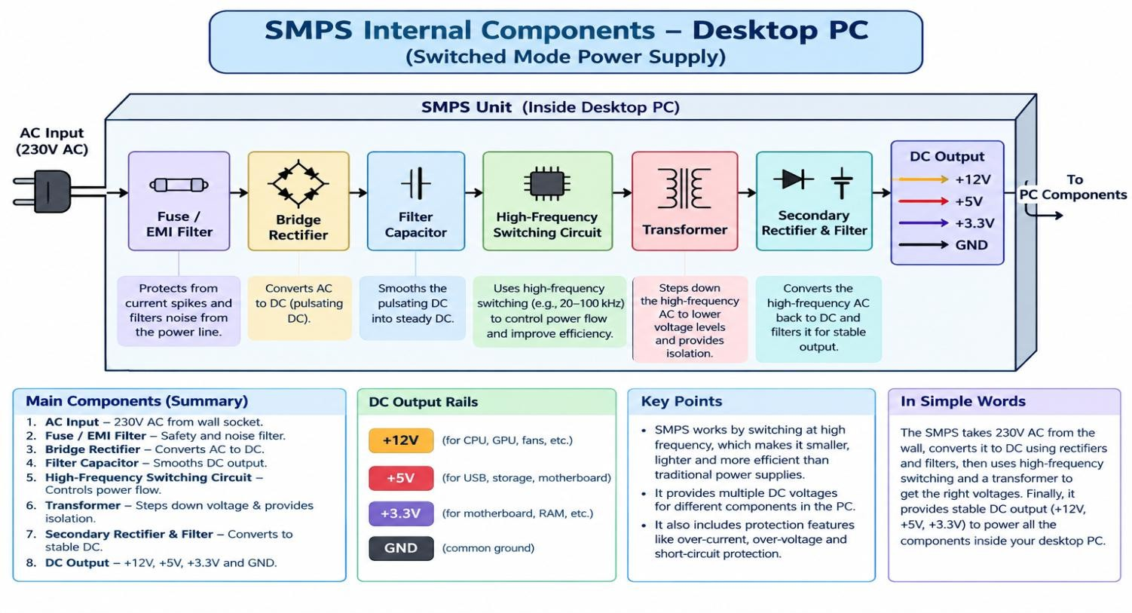

3: Power Connectors

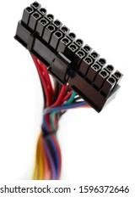
Name: ATX 24-Pin Motherboard Connector
Powers: It supplies the main power to the motherboard.
Safety Tip: Turn off and unplug the computer before connecting or disconnecting it. Make sure the connector is correctly aligned and fully inserted.

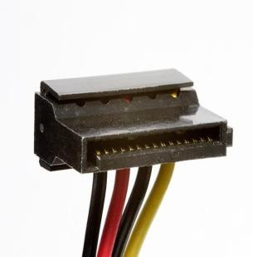
Name: SATA Power Connector
Powers: It supplies power to SATA HDDs, SSDs, and optical drives. Safety Tip: Align the L-shaped connector correctly and never force it into the device.

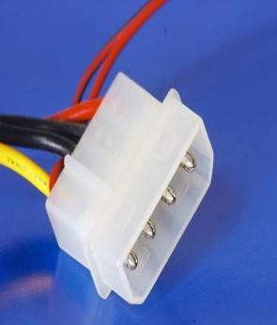
Name: Molex 4-Pin Connector
Powers: It is mainly used for older hard drives, optical drives, fans, and other older peripherals.
Safety Tip: Switch off and unplug the computer before connecting or disconnecting the Molex connector. Do not pull it by the wires.

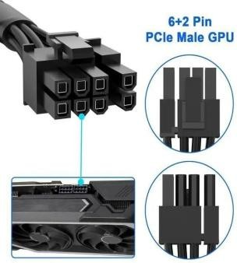
Name: PCIe 6/8-Pin Power Connector
Powers: It provides additional power to a dedicated graphics card (GPU). Safety Tip: Use the PCIe cable, not the CPU/EPS cable, and make sure it is completely inserted into the GPU

4: Steps to Connect SMPS in a New Gaming PC

Step 1: Turn off the power
Make sure the PC is switched off and the SMPS is disconnected from the wall power.

Step 2: Install the SMPS
Place the SMPS inside the PC cabinet and secure it using the screws.

Step 3: Connect the motherboard
Connect the 24-pin ATX power cable from the SMPS to the 24-pin motherboard power connector.

Step 4: Connect the CPU power
Connect the 4+4-pin CPU/EPS cable to the CPU power connector on the motherboard.

Step 5: Connect the graphics card
Connect the PCIe 6-pin, 8-pin, or 6+2-pin cable, depending on the GPU requirement, to the graphics card.

Step 6: Connect the storage devices
Connect a SATA power cable from the SMPS to the SATA SSD, HDD, or optical drive.

Step 7: Connect other peripherals
If required, connect Molex power connectors to compatible fans or older peripheral devices.

Step 8: Check all connections
Make sure every connector is properly inserted and locked. Do not force any connector.

Step 9: Connect AC power
Connect the SMPS power cable to the wall socket or a suitable UPS.

Step 10: Turn on the PC
Switch on the SMPS and then press the computer's power button. Check that the PC starts normally.

